
Web-Based Application Development
(CSE3023)

Lab Report 3

Group:
K1
Prepared by:
Wong Cai Yi S76084
Program:
Bachelor of Computer Science (Software Engineering)
with Honours

Date of Submission: 15 April 2026
Lab Exercise
Header.jsp
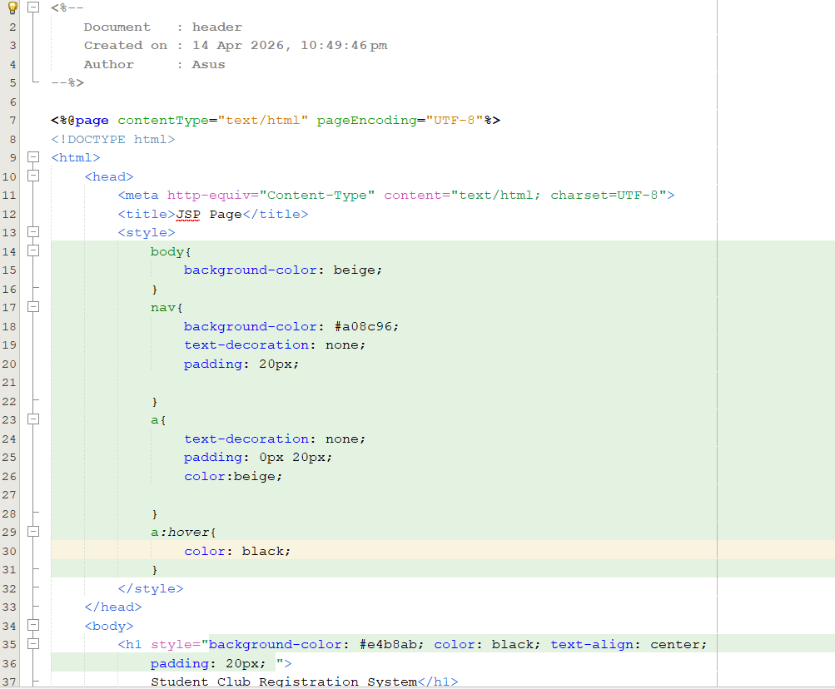
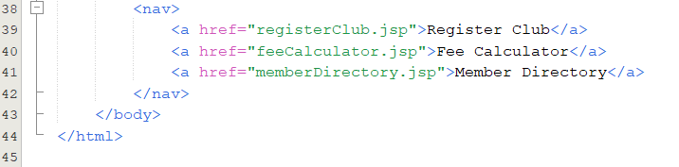

Footer.jsp
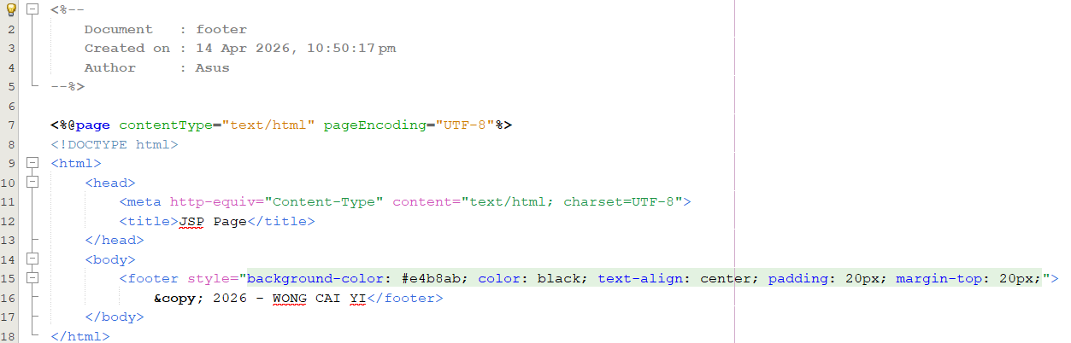

registerClub.jsp
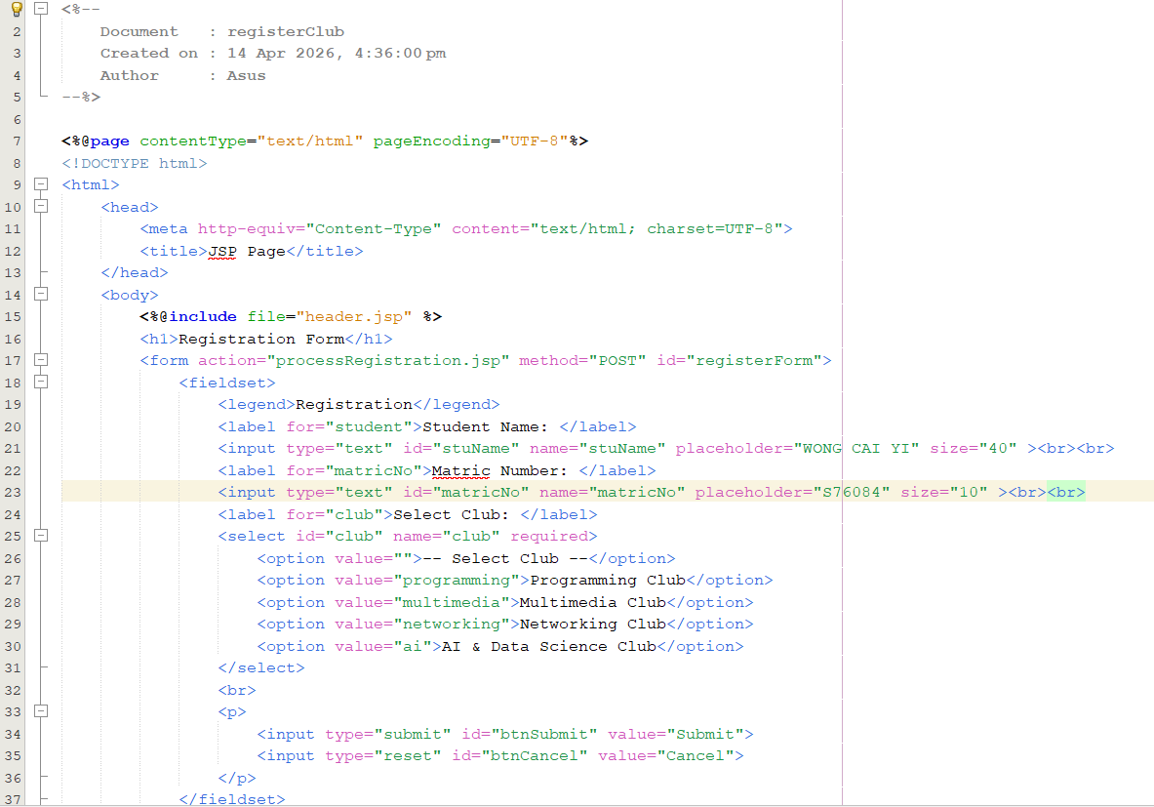
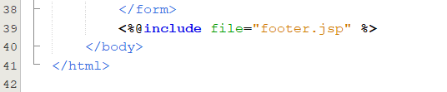

processRegistration.jsp
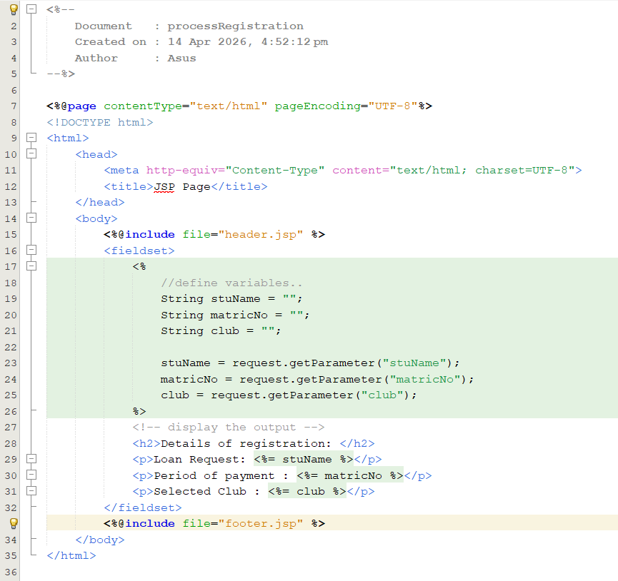

feeCalculator.jsp
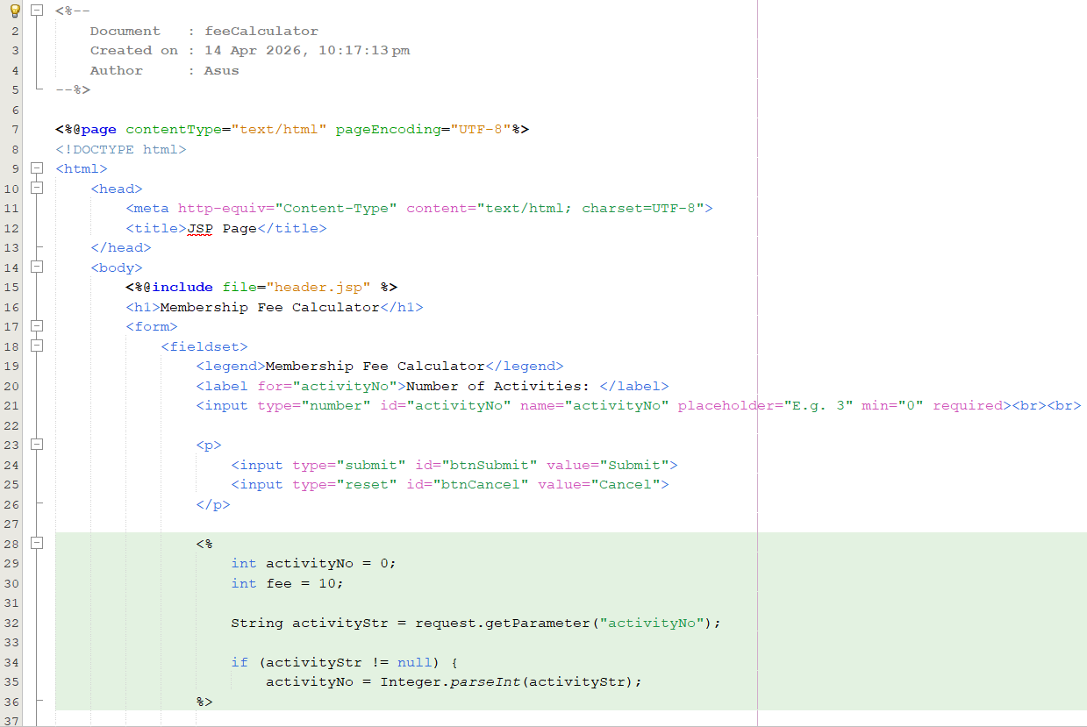
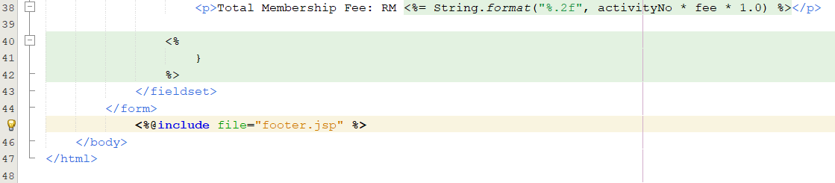

memberDirectory.jsp
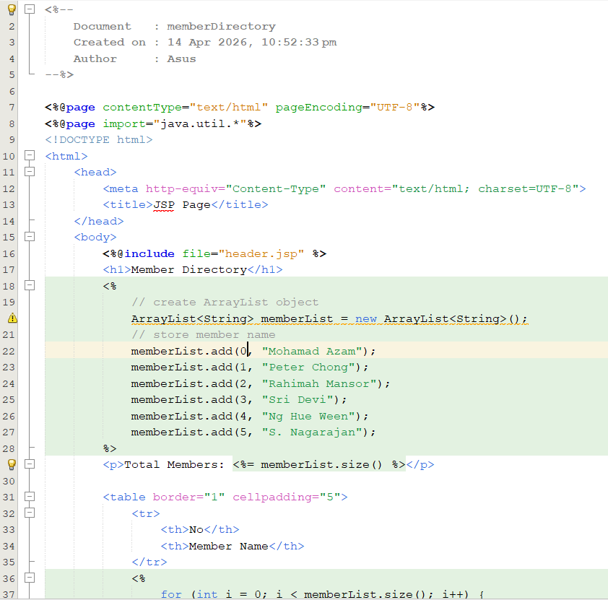
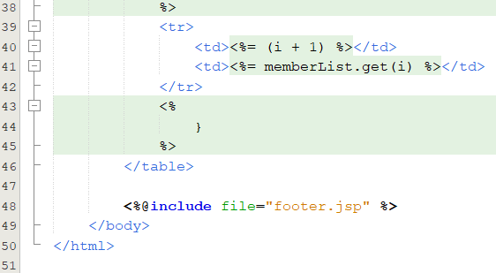

Output
